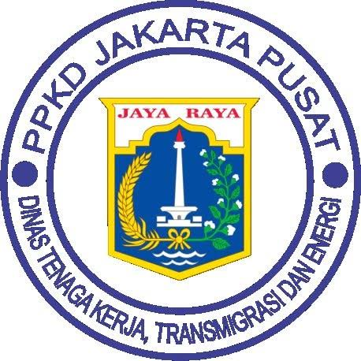
PPKD HOTEL

MISCELLANEOUS FORM

Guest Name Room No.

Description | Amount
Total

Cashier : Guest :

